Readme draft

Name : “A look into our universe”

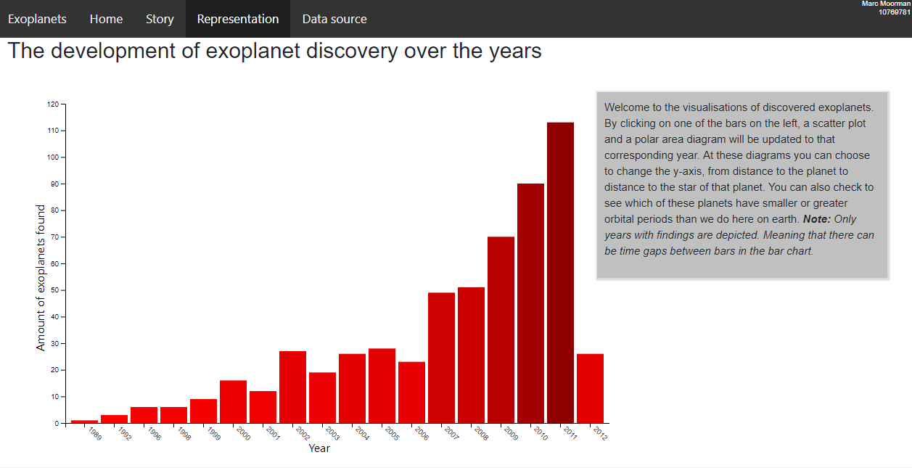

The purpose of this visualization is to give people an easy look into our discovery of our universe. Simple characteristics are shown and explained. So no prior knowledge is needed for this project. Its meant for everyone!

Marc Moorman

Copyright—MIT license

External sources:

The code for drawing the polar diagram is used from: <https://bl.ocks.org/curran/94f1376b946c9d217014> The code for the polar area diagram has no license.

The data depicted in this visualizations are from: <https://www.kaggle.com/eduardowoj/exoplanets-database/data>

For drawing the scatter plot and bar chart this tutorial is used: <http://alignedleft.com/tutorials/d3> this tutorial has a copyright

Images:

The shortcut icon is from: <https://phys.org/news/2014-12-percent-earth.html> The shortcut icon allows students to use their website for their own work without permission.

Radio buttons is made with bootstrap. Code is found on: <https://www.w3schools.com/bootstrap/bootstrap_forms_inputs.asp> We3schools has his own copyright license.

For the dropwdown menu:

All directories are copyrighted by one person, me.

No special mentions are needed